Descent with Modification
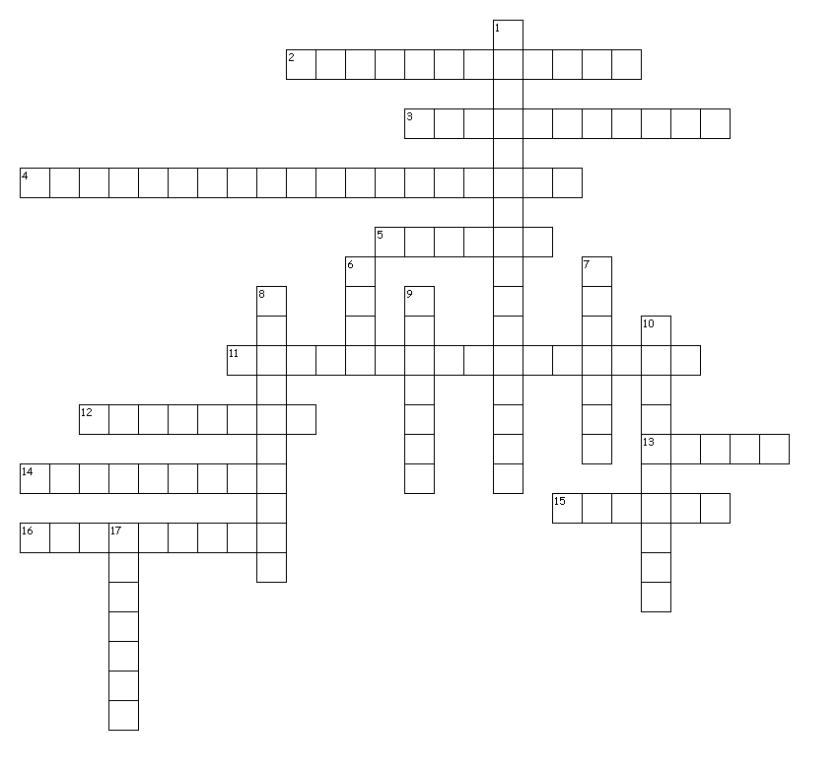
Across
2. A field of biology that seeks to understand why organisms are found in a particular geographical space
3. Generation Belief that living organisms can arise from non-living matters
4. Theory that explains why unrelated species share common features or structures
5. Author of On The Origin Of Species By Means Of Natural Selection
11. Process whereby favorable traits become more common in successive generations
12. Creator of the binomial naming system
13. Proposed Theory of Uniformity
14. Structures found in current organisms that seem to have no apparent function
15. Ship that Darwin sailed in
16. Functionally similar structures found in unrelated organisms
Down
1. The missing link
6. Modern evolutionary biologist who brought together various discipline of science to form the modern synthesis of evolution
7. Proposed that population will grow exponentially if resources are available
8. Geological theory that states geological changes are due to accumulations of smaller changes
9. Contemporary of Darwin who independently came up with the idea of natural selection
10. Anatomically similar structures found in organisms that share a common ancestor
17. Proponent of the soft inheritance theory

