**Structures of Some Biological Molecules**

1. Carbohydrate
   1. Glucose/monosaccharides

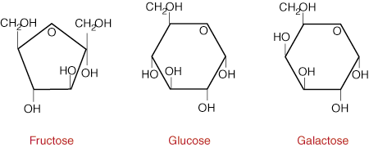

* 1. Polysaccharide

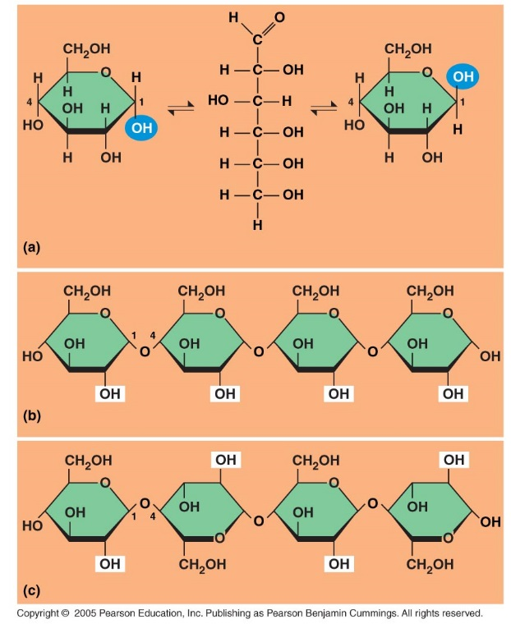

* 1. Disaccharide

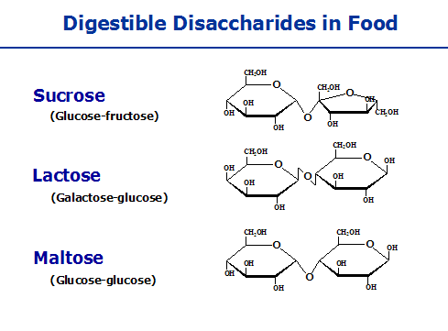

1. Protein
   1. Amino acids and polypeptide

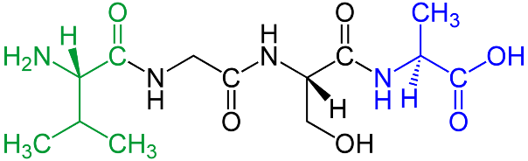

1. Lipids
   1. Cholesterol
   2. Fatty acids
   3. Phospholipids

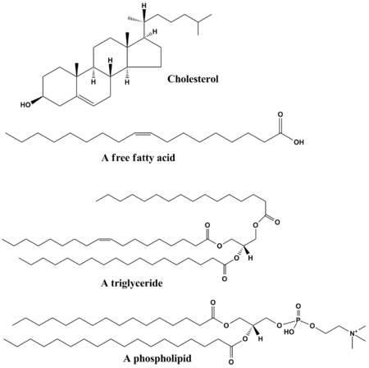

1. Nucleic acids
   1. Nucleotide

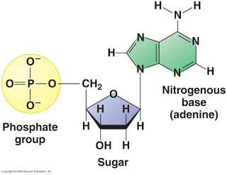

* 1. ATP



* 1. Purine
     1. Guanine
     2. Adenosine
  2. Pyrimidine
     1. Cytosine
     2. Uracil
     3. Thymine

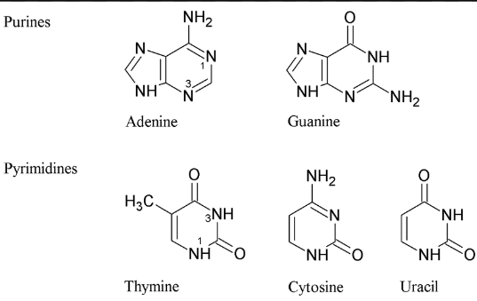

e. DNA and RNA

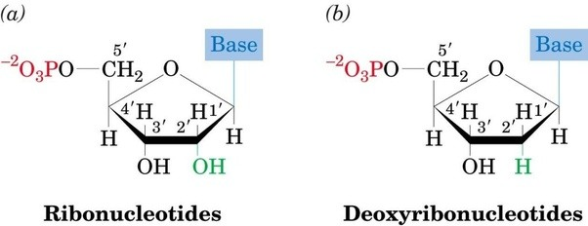

1. Functional groups

